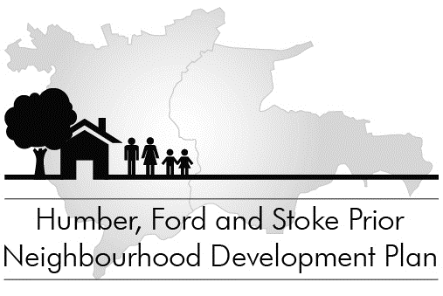

Our Emerging Plan

Drop-in at any time on

Thursday 16 October from 4-8pm Risbury Village Hall

Friday 17 October from 4-8pm Stoke Prior Village Hall

to discuss the proposals and options in Our Emerging Plan, which has been delivered to every household and business in the neighbourhood.

- Free tea, coffee and cakes

Don’t forget to return your response slip by Sunday 19 October

Supporting Communities in Neighbourhood Planning Programme


