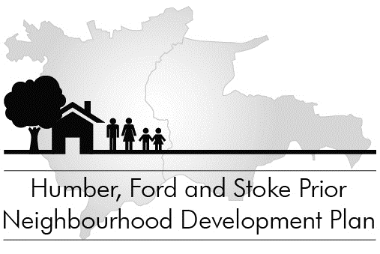

Summary of Examiner’s modifications to Neighbourhood Plan
May 2016

The independent Examiner’s report recommends that our Neighbourhood Plan can go to referendum subject to the modifications proposed in the report. She particularly commends the consultation process for the Plan’s development.

The Examiner reviewed the Plan for consistency with national and local planning policies, and she proposed modifications to some policies to ensure this. Her report was considered by a meeting of the NDP Steering Committee on 16 May, which made the required modifications and submitted the final Plan to Herefordshire Council. The Examiner’s report is available on the NDP pages of the parish website (www.hfspgroup.org.uk) or can be obtained from the Clerk.

The central policies of the Neighbourhood Plan are broadly unchanged by the Examiner. However, she required some details of some policies to be deleted or re-worded where these were considered to be too restrictive on sustainable development or delivery of new housing, and therefore contrary to national planning policy.

Apart from technical corrections and minor changes to wording to strengthen or clarify policies, and changes to supporting explanatory text, the major modifications made to the Plan’s policies by the Examiner are, in summary:

Policy HFSP1: Promoting and sustainable and thriving community
- Removal of mention of addressing excessive vehicle speed and the effect of heavy goods traffic from paragraph (b) of the policy, as these issues are more appropriately dealt with through non-planning means, such as our Parish Action Plan.
- Removal of last two paragraphs of the policy (about when this policy applies), as these are considered unnecessary and confusing.
Policy HFSP3: Meeting housing needs: housing development
- Removal of the phasing element of this policy, as this is considered too prescriptive and may prevent sustainable development and housing needs being met.
Policy HFSP6: New homes in Steen’s Bridge
- Change to wording of paragraph (f) concerning a footpath link between Humber Close and Stoke Prior Lane: contributions from development towards this should be made “whenever possible”, instead of being required, as this was considered too restrictive on development. This issue should also be tackled through the Council’s Parish Action Plan.
Policy HFSP7: Provision of affordable housing
- Paragraph (iv), relating to provision of housing for older people, is changed so that this is now “encouraged” rather than required for developments of more than 3 units in rural exception sites, as this was considered too onerous and may affect the viability and deliverability of such developments.
Policy HFSP8: Design criteria for housing and sites
- Government policy means that neighbourhood plans cannot set out any local technical standards or requirements for new dwellings; these are instead covered by the county’s Core Strategy policy SD1. Policy HFSP8 therefore now says that new housing will be encouraged – rather than required – to include sustainability measures such as energy and water conservation, but Core Strategy Policy SD1 effectively means that these requirements still exist.
Policy HFSP10: Retention of community services and facilities
- Amendment to policy on possible loss of the Post Office, as this was considered too restrictive: proposals which would lead to the loss of the Post Office will not be supported unless an alternative facility is available or is no longer required or viable, in accordance with Core Strategy SC1.
Policy HFSP11: Highways and transport infrastructure
- Paragraph (d) of the policy is changed from a requirement that development should not lead to a significant increase in the speed or volume traffic, to a requirement that development should demonstrate that its impact on the local road network is acceptable.
Policy HFSP14: Surface and foul water drainage
- The requirement for new development to address existing drainage problems has been removed, as this was considered unfeasible and inappropriate.
Policy HFSP16: The natural environment
- Many of the green spaces identified as important within or adjacent to the settlement boundaries are removed from Table HFSP16, as not meeting the strict criteria for such local green spaces in the National Planning Policy Framework. Almost all of these lie outside of the settlement boundaries, however, so they still have general protection from new housing development.

The referendum will be held on Thursday 28 July 2016, during Community Week. It will be organised by Herefordshire Council, and full details of polling and how to apply for postal or proxy votes will be published by the Electoral Services department. If a simple majority of those voting agree, the Plan will be adopted by Herefordshire Council as part of the local development plan, and will become local planning policy.

Before the referendum every household and business in the Group Parish will be given a copy of the final Neighbourhood Plan by the Parish Council.

Philip Brown, Clerk to the Council
01885 400696 clerk@hfspgroup.org.uk www.hfspgroup.org.uk

